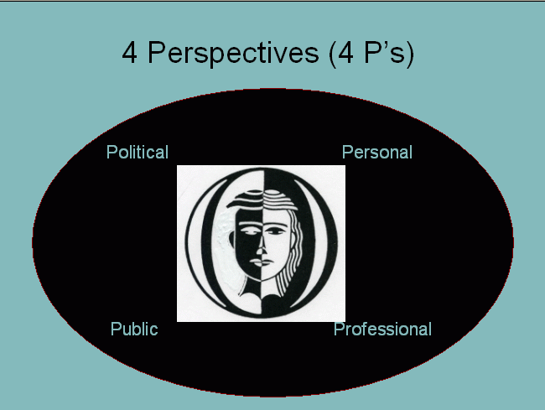
nnnnnnn

DEFINITIONS: The quadrant represents four core aspects of women’s lives, each of which may overlap; all of which may be foreground for a discussion.

Personal: represents inner (spiritual) and outer (family, friends) relationships; support and community.

Professional: focuses upon education, career selection and
trajectories, workplace environments; salaries.

Public: addresses public stereotypes and images; recognition.

Political: includes conflict and change; representation; issues.

